Chapter 1 The force due to gravity
Chapter Test Total marks 46

Name: ______________________ Class: ______ Date: ______
A data sheet with appropriate physics constants will be provided for this test.
Question 1
A researcher measured the strength of the gravitational field (g) of an object of mass (m) at a range of distances (r) from the object and plotted the inverse of the square of the distance from the object against gravitational field strength. The graph below shows the plot.

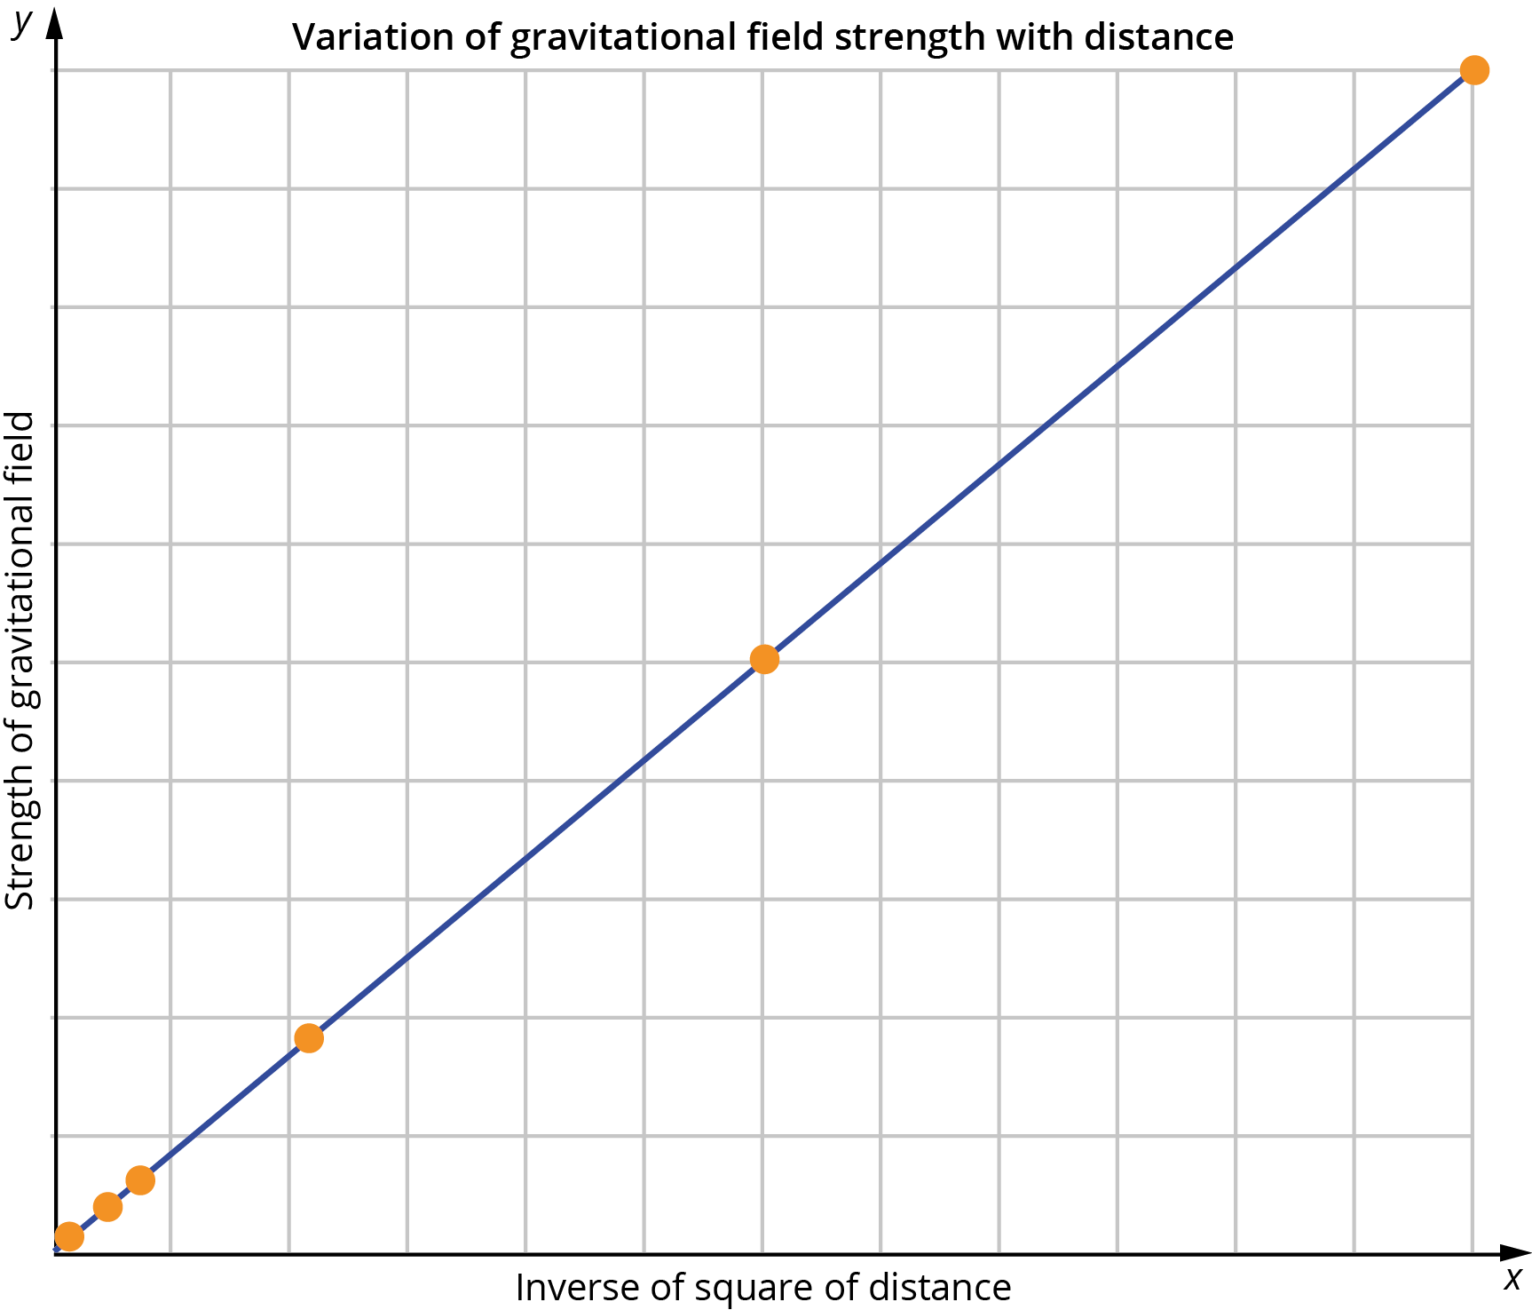

- Describe what the shape of the graph indicates about the relationship between gravitational field strength and distance from the object. (2 marks)

The researcher repeats the experiment with a second object, with a mass half the value of the object in the first experiment. Again, the inverse of the square of the distance from the object against gravitational field strength is plotted on a graph. The researcher finds that the gradient of the line in the second experiment is half that of the gradient in the first experiment.

- What does the gradient (slope) of the line represent? Include a mathematical expression using the appropriate physics symbols to show what the gradient means.
(2 marks)

Question 2
- Calculate the force of attraction that a 250 kg satellite, orbiting the Earth at a height of 36 000 km, experiences from the Earth’s gravitational field. (3 marks)

- Discuss the extent to which the gravitational field of the Sun may influence the orbit of this satellite when it is between the Earth and the Sun. Support your answer with appropriate working. (6 marks)

Question 3
The mass of the Sun is about 1000 times greater than the mass of Jupiter.
- Compare the force of attraction the Sun exerts on Jupiter to the force of attraction Jupiter exerts on the Sun. Support your answer with an appropriate explanation.
(3 marks)

- Compare the acceleration that Jupiter will experience due to the Sun’s gravitational attraction to the acceleration that the Sun will experience due to Jupiter’s gravitational attraction. Explain your answer. (3 marks)

Question 4
In November 2014, the spacecraft Rosetta arrived at the comet Churyumov–Gerasimenko and went into orbit around it at a distance of approximately 1 km.
The comet is shown below and is thought to become increasingly porous beneath
its surface.
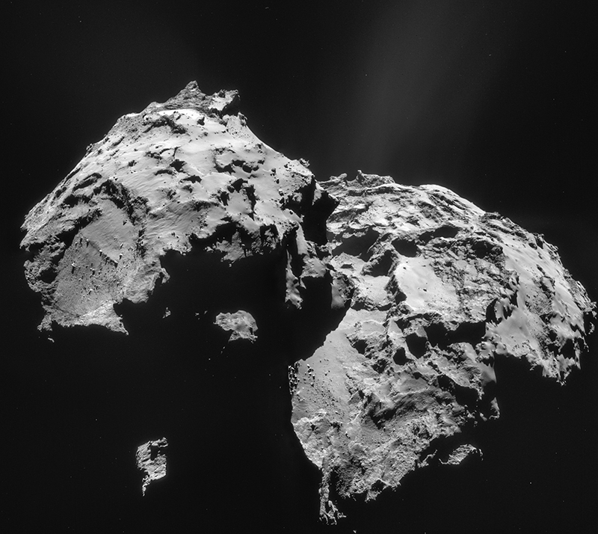
Source: ESA/Rosetta/NAVCAM, CC BY-SA IGO 3.0.

- Given the Rosetta spacecraft has a mass of 1230 kg and the comet’s mass is estimated to be 1 × 10¹³ kg, what is the force of attraction between Rosetta and the comet? (3 marks)

- When using Newton’s law of universal gravitation, the distance is taken from the centre of the two objects. What assumption underlies this way of determining the distance separating the two objects? Explain why this assumption may not be appropriate for the attraction between the comet and the Rosetta spacecraft. (2 marks)

Question 5
While conducting an experiment in a plane, a student uses a set of scales to measure the force of the gravitational field on a 7.50 kg object. The scales give a reading of
73.1 N.
- What is the strength of the gravitational field acting on the object? (3 marks)

- Determine the height at which the plane is flying in order to provide the measurement taken. (5 marks)

Question 6
A physicist calculates the gravitational potential energy of an 85 kg object 100 km above the Earth’s surface, as follows.
E_{P} = mgh = 85 × 9.8 × 1 × 10⁵ = 8.33 × 10⁷ J
Explain why this is not the correct value, and show that the correct value is
8.06 × 10⁷ J. Show clear working to support your answer. (6 marks)

Question 7
A 187.0 kg vehicle is sent to the planet Mars to explore its surface. While travelling its surface it encounters Mount Olympus which, at an elevation of 2.117 × 10⁴ m, is the tallest known mountain in the solar system. If the gravity on Mars is 3.71 m s⁻², how much work does the vehicle do in travelling to the top of Mount Olympus? Give your answer in the appropriate number of significant figures. Assume that the gravitational field strength on Mars does not change significantly over the journey up the mountain.
(4 marks)

Question 8
A 600 g weather balloon with a payload of 3.75 kg rises to a height of 34 620 m before bursting. Ignoring air resistance, at what velocity will the payload strike the ground if its breaking balloon fails to open? Assume that the gravitational field strength does not change significantly over the distance it falls. (4 marks)

